16.12.2018 – First LoRa Radio test

The best place where we could test the range and throughput of our radio in the center of Cracow are probably: Blonia Park and Kosciuszko Mound, so we decided to choose these spots. As a transmitter we used LoRa Ra-02 module (fitted with 17 cm long antenna) with Raspberry Pi and TTGO with LoRa onboard as receiver. To enhance the signal, our base station was equipped with 15 dB Yagi antenna (without reflector, that is important when considering the results). Before we had empirically proven that the Spreading Factor set to the value of 7 gives the best results, so we didn’t change it. The frequency band was equal to 433 MHz. We wanted to observe how radio communication changes with the changing velocity and distance.
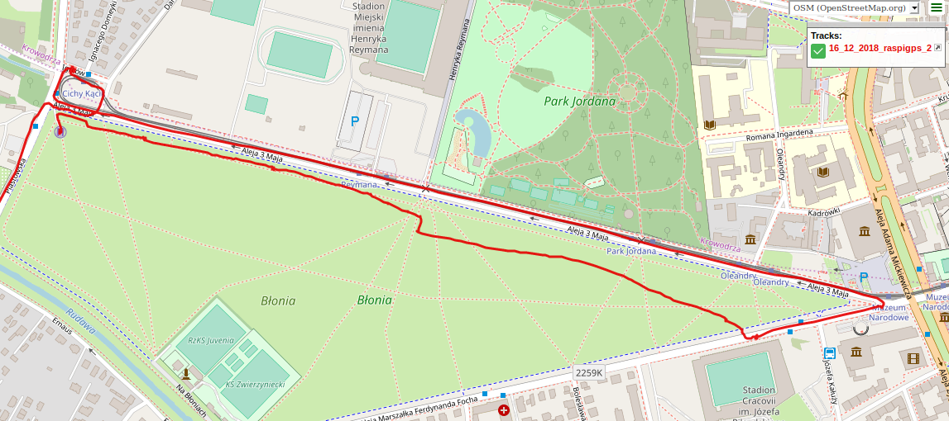

This table shows some correlations during the 1.2 km long walk in straight line from the base station.
Length of the packet | Delay between sending packet (ms) | Approximate distance from base station (m) | Packets per second | Percentage of received packets | Average RSSI (dBm)
30 | 300 | 0-250 | 3.28 | 98.27% | -96
20 | 300 | 250-300 | 3.26 | 99.40% | -97
20 | 500 | 300 | 2.03 | 100% | -97
10 | 500 | 300 | 1.99 | 97.30% | -99
10 | 800 | 300 | 1.33 | 81.08% | -100
10 | 300 | 300-850 | 2.81 | 85.48% | -117
10 | 500 | 850-1200 | 1.19 | 59.75% | -124

Generally, the percentage of received frames is quite satisfactory, except the last measurement. That low value was caused by losing radio connection for over a minute, about 17.4% of packets were lost then.
RSSI varied from -56 to -133 dBm, it decreases as the distance between transmitter and receiver increases, what can be observed on a chart below.

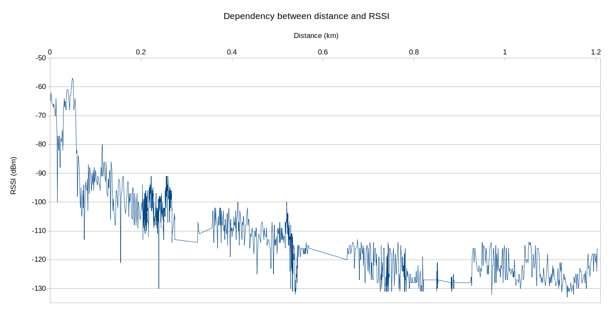

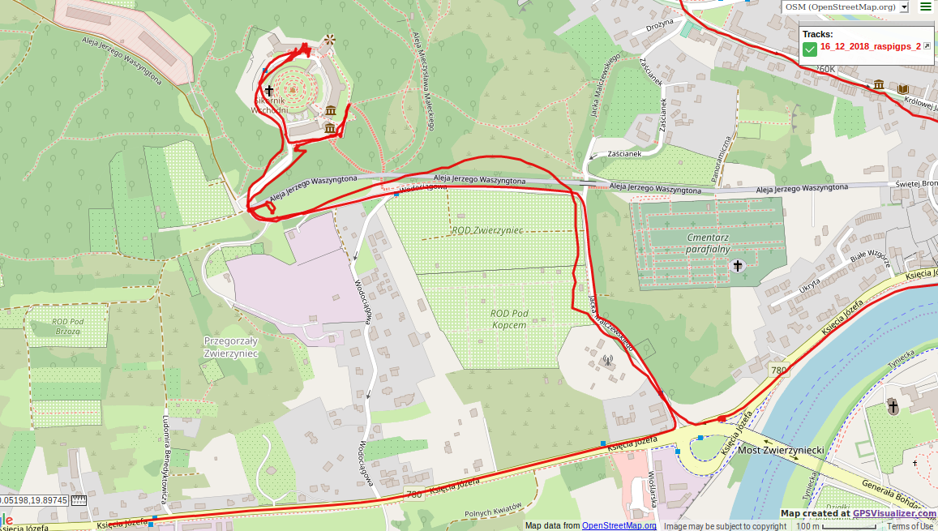
Then we arrived on Kosciuszko Mound and checked how does the velocity affect the communication. We were driving about a kilometer away from base station reaching the max. speed of 47.6 km/h.

Some statistics:
Radio frequency: 433 MHz
Spreading factor: 7
Length of a packet: 20
Percentage of received packets: 63.69 %
Packets per second: 1.26
Average RSSI: -118 dBm
Comment: We have proven that enclosed space and velocity do not do not restrain radio contact – although it is hindered, receiving packets is possible. The percentage of received frames is low – it is strongly connected with distortions caused by trees and some buildings, enclosed space and increasing distance.

Being about 733 meters away from base station (in a straight line), we got out of the car and check the parameters. The results from that spot:
Radio frequency: 433 MHz
Spreading factor: 7
Length of a packet: 10
Percentage of received packets: 63.68 %
Packets per second: 1.26
Average RSSI: -129 dBm
Comment: Unfortunately, the number of received packets was small. Probably it was caused by too many impediments at the Fresnel zone and differences in elevation.

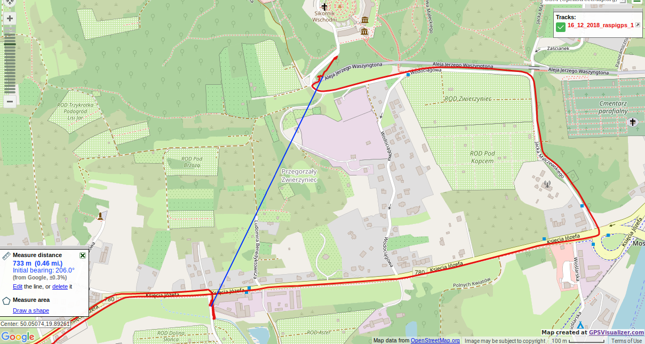

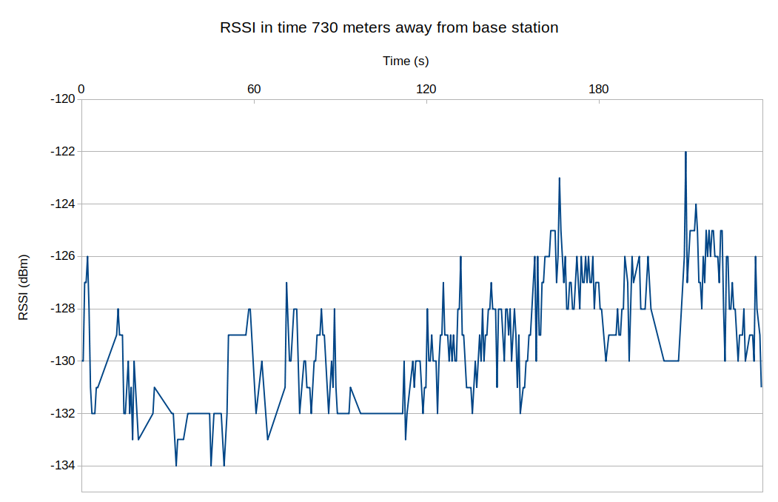

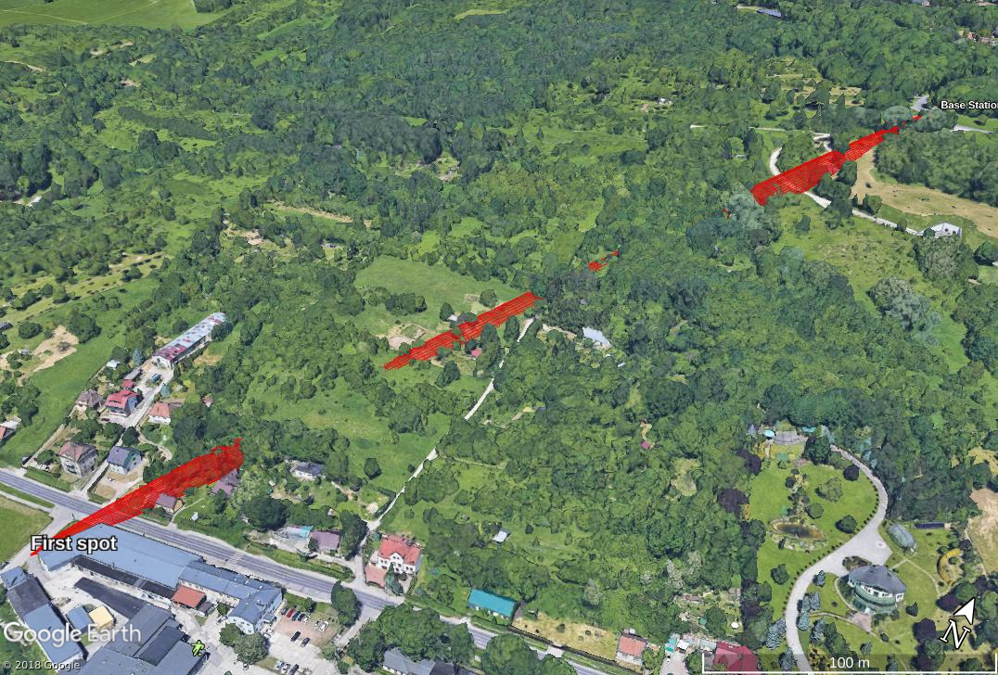
A visualization of Fresnel zone

As the next spot we chose the place which was about 1.6 km away from base station and we have reached contact. We were sure that we saved the log from that attempt but, regrettably, any data has been saved… One thing that we can present is the visualization of Fresnel zone. As it can be seen, it isn’t so disrupted as previous one so probably the results would be better, too.
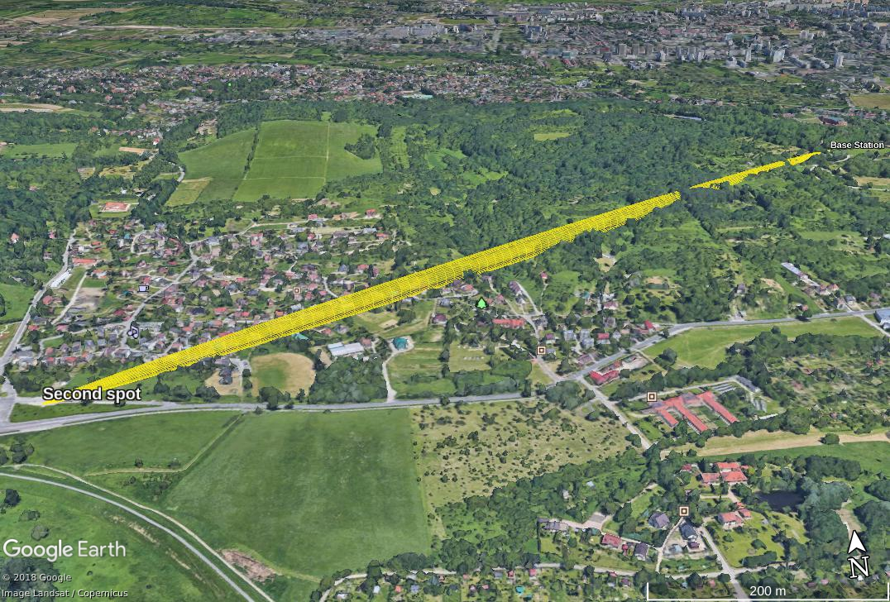

General conclusion:
First Radio test wasn’t bad but we expected that the results would be better. Now we now how we should deal with yagi antenna to enhance the signal – following the trajectory of transmitter movement is the key.
The correlations between the signal strength and distance/velocity were clear, so now we want to focus on the range and throughput – we should choose the place where there won’t be a lot of obstacles – it will simulate best the conditions in which our can will descending during finals (we hope so!).

